INITIAL QUESTIONNAIRE:

Date:.............................

Name of client: ………………………………………………………………………………………………………….

Date of event: ……………………………………………………………………………………………………………

Type of Event: ……………………………………………………………………………………………………………

Location of event/ Venue..………………………………………………………………………………………

……………………………………………………………………………………………………………………………………..

Your contact number:............................................................................................................

Your email address: …………………………………………………………………………………………………

**Details:**

| Theme: |  |
| --- | --- |
| Preferred Colours: |  |
| Personal requests, special effects, additional notes |  |
| Potential Budget available: |  |
| If you have any mood boards, look-books, Pinterest boards or your personal inspiration, please list them here or add links: |  |
|  |
|  |
|  |

If you have already booked any event planners, contractors or vendors, please list them below:



Please email this form to us at [kaja.jedrak@enchantmentwise.com](mailto:kaja.jedrak@enchantmentwise.com) and we will contact you within 5 working days with further information.

This form is confidential and will not be shared with any third party, unless approved by both the Client and Enchantment Wise… Team.

**Thank you for choosing Enchantment Wise…**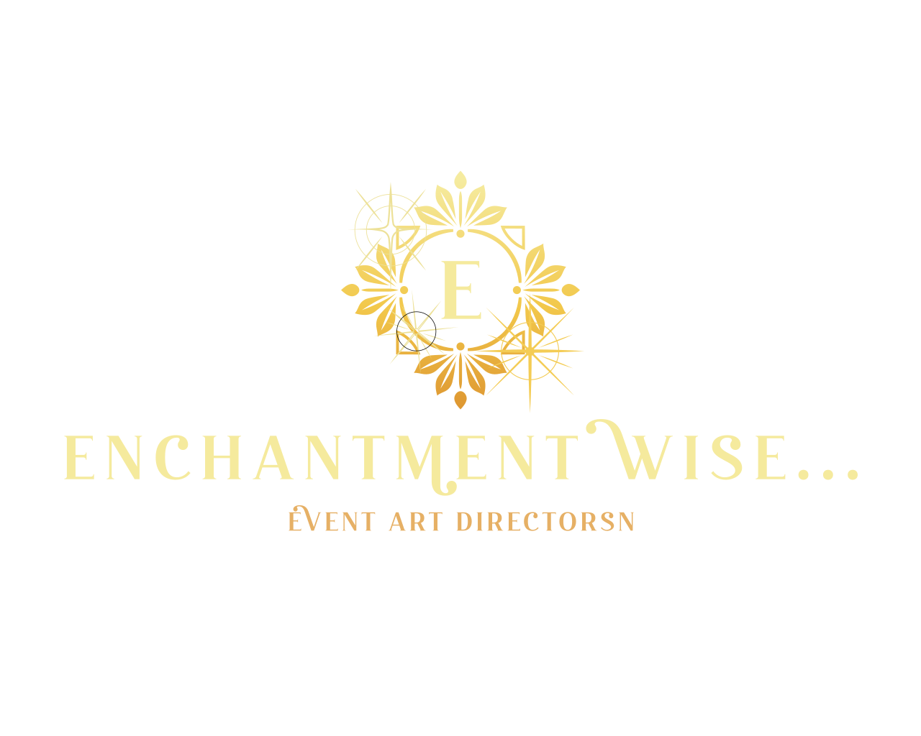

**We promise to deliver the party of your dreams!**